

Searching EBSCO Discovery Service Help Sheet
EBSCO Discovery Service
Help Sheet
The Basic Search Screen lets you create a search with limiters, expanders, and Boolean operators. Because of the customization options available with EBSCO Discovery Service, your interface options may vary.
To search EBSCO Discovery Service:
- On the Basic Search Screen, enter your search terms in the Find field.
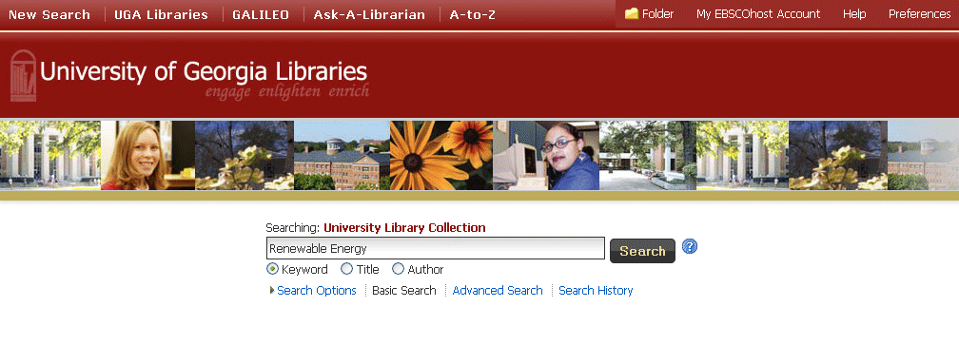
- If you want to use any of the optional Limiters or Expanders, click the Search Options link.
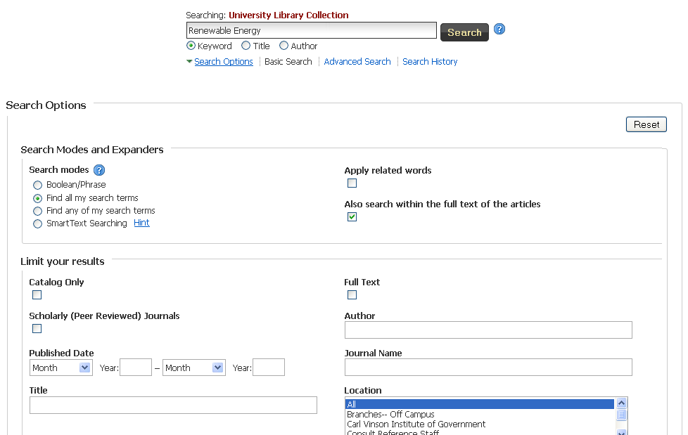
- You can use a specific Search mode, such as "Find all of my search terms," or "SmartText Searching"; apply Limiters such as Full Text or Publication type; or use search options that expand your search, such as "Apply related words."
- To close the Search Options, click the link again.
- Click the Search button. The Result List displays.
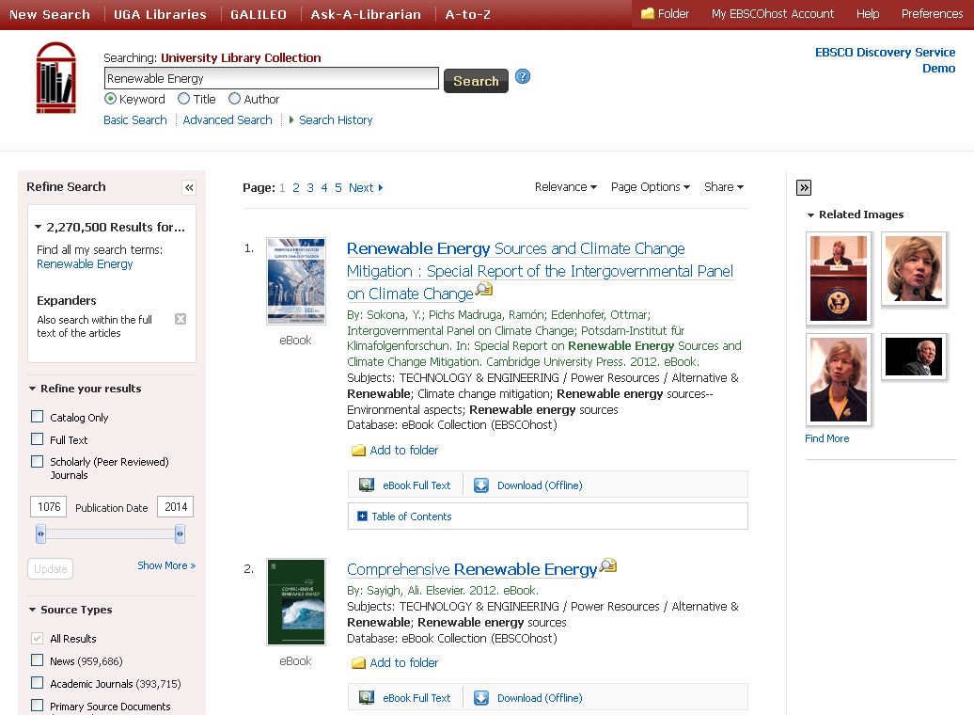
The search field is displayed above the Result List. Your search terms, limiters and expanders are retained. To refine your search, use the limiters and facets in the Refine Search column on the left.
Note: If included in your institution's Discovery Service subscription, you may see a real-time availability message included with your results. This will indicate whether the item is available at your institution or currently checked-out.

